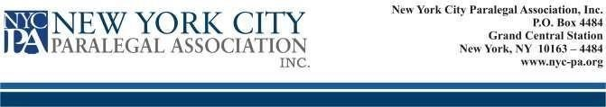
NEW YORK CITY PARALEGAL ASSOCIATION, INC.
PROXY FOR ANNUAL MEETING ELECTION
This is to certify that, I _____________________ _______________________, an
(First Name) (Last Name)
Active Member in good standing with the New York City Paralegal Association, Inc., do hereby designate _________________________ _______________________, to cast my votes for the
following positions:
EXECUTIVE BOARD:
(First Name). (Last Name)
President _________________ _________________

Treasurer ________________ _________________ at the Annual Election of the Executive Board of Directors on October 3, 2022. The said __________________ _{(Name of}
Proxy_{. )}_________________ _{(Title/Position)} is to act as my proxy in voting on this issue only. This authorization is to terminate on October 4, 2022.

__________________________________ Member
Signature
___________________________________ Date

